**Content Generation Tool**

**Overview:**

The provided code is a Python script that creates a simple GUI application using the tkinter library. The application allows users to generate content using the OpenAI API. It provides an interface for users to enter keywords and generates content based on those keywords using the OpenAI Completion API. The generated content is then displayed in a text widget within the GUI.

**API Integration:**

The code integrates with the OpenAI API to generate content. It requires an OpenAI API key, which should be set as an environment variable named `OPENAI_API_KEY`. The key is retrieved using the `os.environ.get()` method and set to `openai.api_key` to authorize API requests.

**Functionality:**

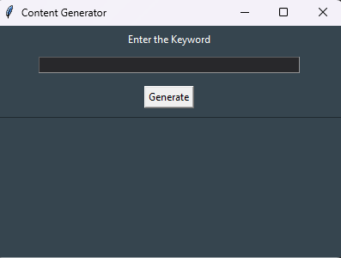

The code defines a function named `generate_content()` that is triggered when the "Generate" button is clicked. It performs the following steps:

- Retrieves the input keywords from the entry widget.

- Calls the OpenAI API using the `openai.Completion.create()` method, providing the input keywords as the prompt.

- Retrieves the generated content from the API response.

- Displays the generated content in the text widget within the GUI as shown below.

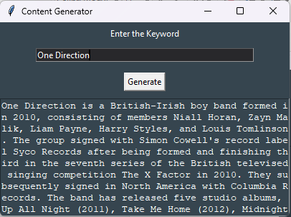

**Deployment:**

To run the code, make sure to have the necessary dependencies installed, including the `openai` and `tkinter` modules. Set the `OPENAI_API_KEY` environment variable to your actual OpenAI API key before running the code. Then, execute the script, and the GUI application window will appear. Enter the desired keywords, click the "Generate" button, and the generated content will be displayed in the text widget.

**Error Handling:**

The code includes error handling to handle potential exceptions that may occur during the content generation process. The following error handling mechanisms are implemented:

The try-except block is used to catch exceptions that might occur during the API request or response handling.

If an error occurs, an appropriate error message is printed to the console.

The error message can be customized or displayed to the user in the GUI application, depending on the specific requirements

**Challenges:**

While implementation I faced the following challenge:

**Handling API errors:** During API requests, I encountered problems involving invalid API responses.

**Conclusion:**

The provided code demonstrates a basic implementation of using the OpenAI API to generate content within a GUI application. It showcases how to integrate the OpenAI Completion API for content generation and use the tkinter library to create a simple user interface. This code can be further enhanced and customized to meet specific requirements, such as adding error handling, improving the user interface, or incorporating additional functionality based on the needs of the application.